EXP. 1 : DESIGN AN LED FLASHER

**CIRCUIT DIAGRAM :**

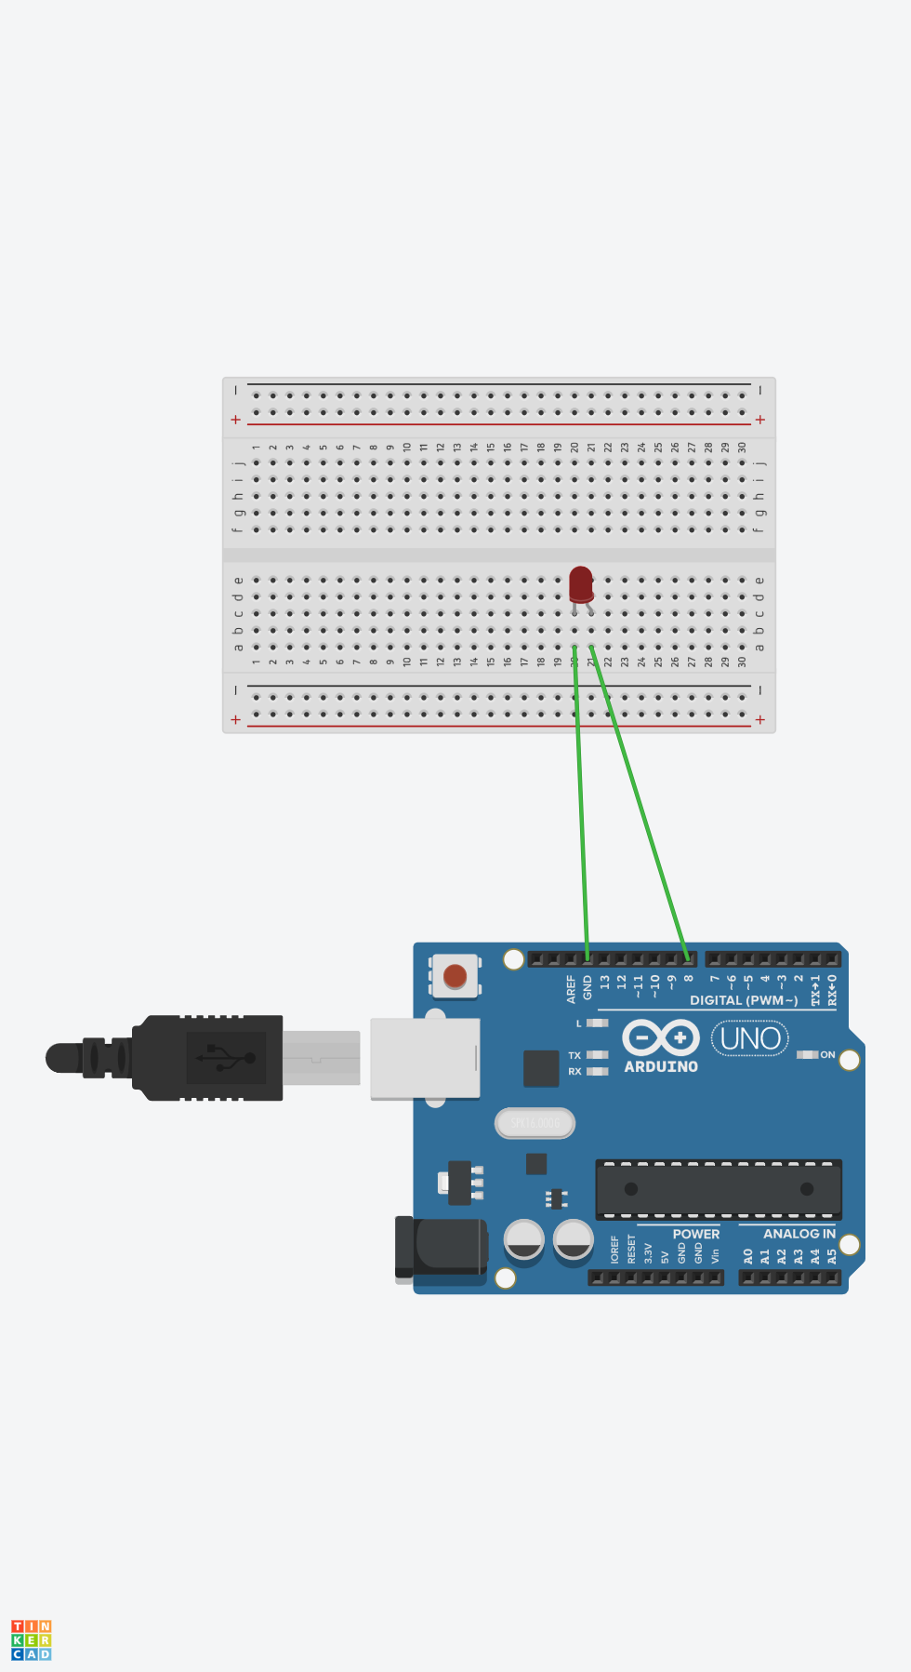

THEORY

CONCEPT USED :

*In this experiment first we used the basics of electronics like connections on breadboard, connecting the led to the breadboard, then concept of Arduino connections and the codingpart of Arduino.*

LEARNINGANDOBSERVATIONS **:**

*Through this experiment I learnt about the connections in breadboard.*

*I learnt about all the parts of Arduinoand coding for Arduino.*

*The coding for Arduino should be done properly otherwise the total experiment would be changed.*

PROBLEMS*&*TROUBLESHOOTING :

*While doing this experiment some problems are encountered and all of them were resolved.*

*One of those is correctly connecting the positive and negative terminals of LED to the ground and other output pins of Arduino.*

*Some problems are also encountered in the coding part of Arduino, In giving the correct function of output or input to the specified pin.*

PRECAUTIONS :

* We have to check the LED we are using either it is burnt or working.
* *The positive and the negative terminals of the LED should be identified properly.*
* *The connections of LED and Arduino with the help of connecting wires should be done carefully.*

LEARNING OUTCOMES :

From this experiment we can learn the connections on breadboard and the connections of LED with Arduino.

By making connections on breadboard we can improveour creativity skills by connecting the LED’s in different ways.

We can learn the coding for Arduino by using the LED’s.

|  |  |  |
| --- | --- | --- |
|  |  |  |